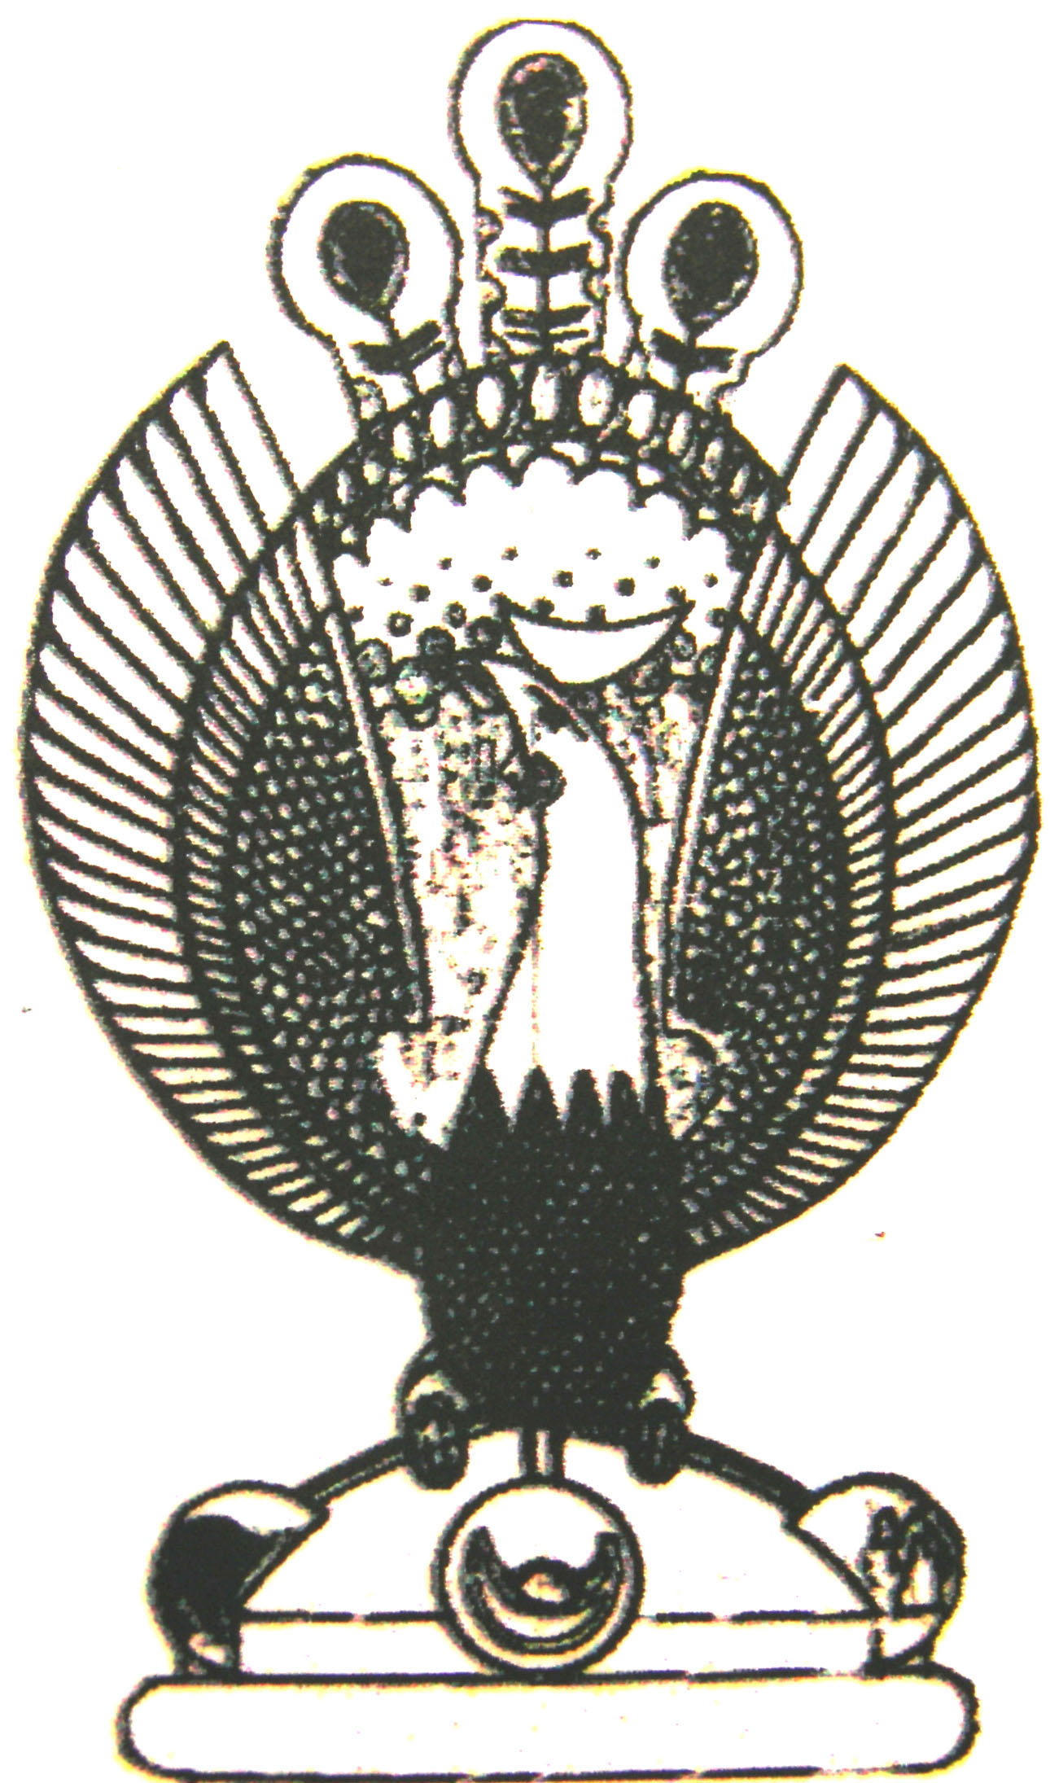

THE HERITAGE
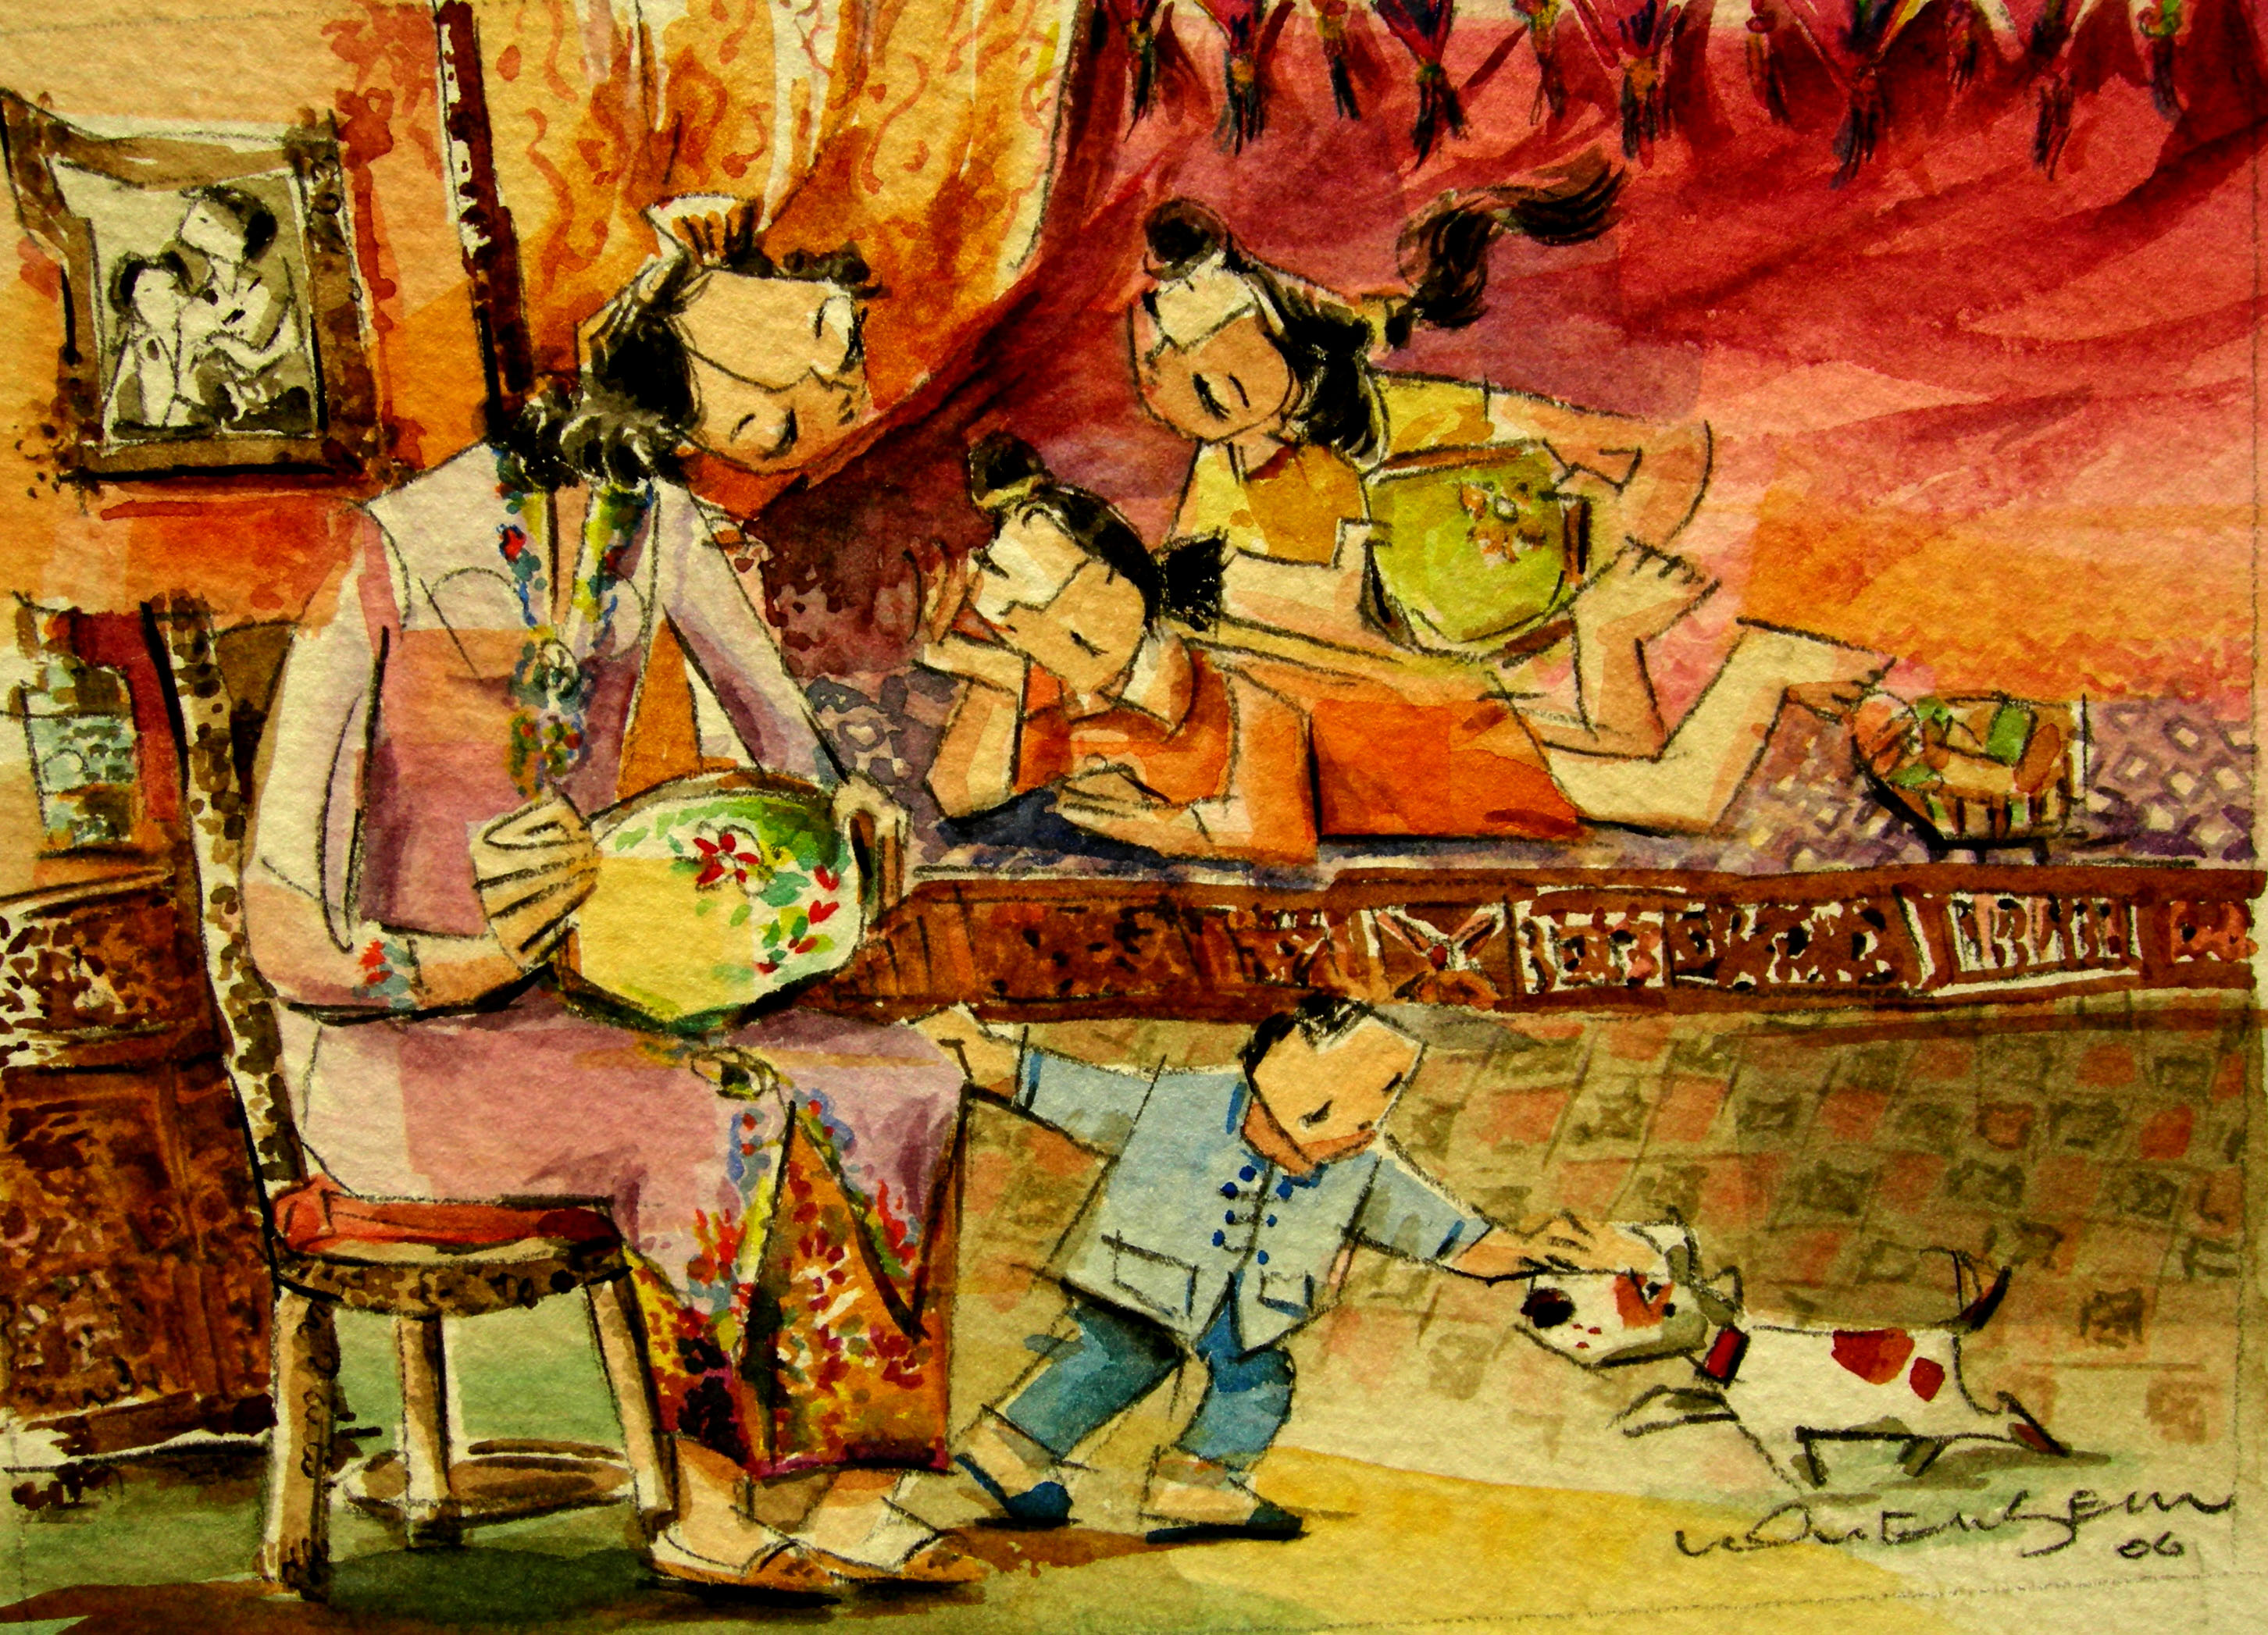
Embroidery
At the very young age of 12, Peranakan girls have been trained in embroidery to attain the skills to perfection.

